Michael Meinz
510 Yonge Street
Toronto, Ontario M7M-7M7
(416) 555-1234
CONTACT INFORMATION

SPECIFIC PLACE OF EMPLOYMENT
OBJECTIVE
To obtain part time, entry level employment as a cashier at Canadian Tire.

PERSONAL PROFILE
INCLUDES FOCUS STATEMENT, FILTER #1 AND COLOUR PACKAGE STATEMENTS
- Enthusiastic, hard-working high school student
- Responsible, co-operative student who works well with others
- Enjoys creating and inventing
- Likes keeping order, producing results quickly and bargaining

EDUCATIONAL ACHIEVEMENTS AND ACTIVITIES
INFORMATION ABOUT SCHOOL IN REVERSE CHRONOLOGICAL ORDER
Gr. 10 student, St. Mary’s High School, Kitchener
- member of Jr. Football Team, 2005
- Honour Roll Semester 1, 2004
- 2nd place Regional Track and Field Meet, long-jump, 2003

John Sweeney Catholic Elementary School, Kitchener (JK – Gr. 8)
- Score Keeper for school basketball games, 2000

PERSONAL ACHIEVEMENTS AND ACTIVITIES
INFORMATION ABOUT ACTIVITIES OUTSIDE OF SCHOOL IN REVERSE CHRONOLOGICAL ORDER
- City of Kitchener Indoor Soccer team, 2000-2006
- Piano lessons, 2005
- St. John Ambulance Babysitting course, 2005

WORK EXPERIENCE
IF YOU HAVE WORK EXPERIENCE, LIST IT IN REVERSE CHRONOLOGICAL ORDER
Councellor-in-Training
Bellewood YMCA Camp, Bellewood, Ontario, August 2005
- planned craft activities for campers aged 6-8
- supervised waterfront activities

JOB SKILLS
INCLUDES FILTER #1 AND COLOUR PACKAGE STATEMENTS THAT RELATE TO SKILLS AN EMPLOYER IS LOOKING FOR
- Punctual and responsible worker
- Able to handle deadlines and work under pressure
- Bilingual – fluent in English and French

COMMUNITY INVOLVEMENT
THIS IS IMPORTANT – IT DOESN’T NEED TO BE AT THE BOTTOM
LIST YOUR VOLUNTEER WORK
Fund raiser, Terry Fox Run
- raised $100 in pledges, walked 10 km., Sept. 2005

REFERENCES
Available upon request

Resume Sections Summary
http://www1.umn.edu/ohr/careerdev/resources/resume/sections/index.html

In general, the sections you choose for your resume depends on the type of resume –
chronological, functional or combination style. There is no set order to the sections but organize it thoughtfully.

Length of your Resume
Your resume should fit onto one page. If your resume is longer than one page, keep in mind that the average employer spends about 35-40 seconds scanning a resume. It is important to eliminate any extraneous words that could distract a reader. It is important that your resume fills your page effectively (adjust margins and type size to achieve a good look).

Contact Information (required)
At the top of your resume, you need to include the following information:
- Name
- Address
- Telephone Number(s)
- E-mail address
The telephone numbers and e-mail addresses are critical, so make sure they are correct and are numbers or addresses you check regularly.
The message you leave for a busy signal or voicemail needs to sound appropriate!. Also make sure your e-mail address is professional (don't use something like "HotBabe@hotmail.com.") This will NOT work for you!

Examples
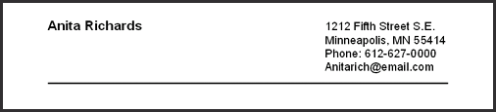


OBJECTIVE (required)
Use this to target your resume to a specific job (State the position and location of where you are applying). The Objective answers the question: Why am I writing this resume?
There is some debate over the inclusion of an objective. Some believe it is redundant while others see it as a framework for the reader to assess your resume.
If you decide to include an objective, it typically contains four parts:
- The "level" of the position (full time, part time, entry, management…)
- The skills you hope to use in the position (look at you inventories and word lists for POWER WORDS OR KEY WORDS)
- The title of the position or the function (cook, waitress, packer…)
- The field or industry in which you hope to work (retail, education, automotive, health care…)
Sample 1:
To use my leadership skills to obtain summer employment as a camp councilor at Camp Clover.

Sample 2:
To obtain part time, entry level employment as a cashier at Canadian Tire.

PERSONAL PROFILE (required for this Careers Course)
This section gives you a chance to tell the employer about yourself.
- Place it near the top of your resume
- No more than one or two sentences
- Information should relate directly to the position you are applying for
- Use your FOCUS STATEMENT and some statements from FILTER #1 (green booklets) and your Colour Package for your strengths

Sample 1:
- Enthusiastic, hard-working high school student with experience working with young children

Sample 2:
- Responsible, co-operative student who works well with others.

Personal Profile
- Energetic, co-operative student
- Manages time well, independent worker
- Has coaching experience

EDUCATIONAL ACHIEVEMENTS AND ACTIVITIES (required)
List any school achievements, especially those that apply to the position you are seeking.
- List the most recent accomplishments first
- A complete list is not necessary, just the most important

Sample:
Gr. 10 student, St. Mary’s High School, Kitchener
- member of Jr. Football Team, 2005
- Honour Roll Semester 1, 2004
- 2nd place Regional Track and Field Meet, long-jump, 2003

John Sweeney Catholic Elementary School, Kitchener (JK – Gr. 8)
- Score Keeper for school basketball games, 2000

PERSONAL ACHIEVEMENTS AND ACTIVITIES (if anything applies here, INCLUDE THIS HEADING)
These are accomplishments and activities outside of school.
Highlight achievements that may not apply specifically to the job you are seeking, but that you are proud of.
- Use short statements
- Be specific about what you have done
- Categorize if you have a list of common things

Sample:
- City of Kitchener Indoor Soccer team, 2000-2006
- Piano lessons, 2005
- St. John Ambulance Babysitting course, 2005

WORK EXPERIENCE (if you have been paid for any work on a regular basis, INCLUDE THIS HEADING)
Do not include this section if you have no work experience.
Look at job descriptions or achievements that are related to your work experience. What can you say about your performance? For example, how many people did you supervise / baby sit / wait on…? Did you have to train anyone? What skills did you develop? What was your biggest accomplishment?
You want to paint a clear picture for the reader of the resume in terms of your success and the skills you have developed. They want to hire people who have been successful.
- List your jobs in reverse chronological order – the most recent position first, the next most recent second, and so on
- State the title for each position, the name of the employer, the date you worked there
- Be consistent in how you format each experience.
- State your responsibilities or the skills you used in this job
- use action words (see handout) to show you are a person who gets things done
- look at personality inventory results

Sample:
Councellor-in-Training
Bellewood YMCA Camp, Bellewood, Ontario, August 2005
- planned craft activities for campers aged 6-8
- supervised waterfront activities
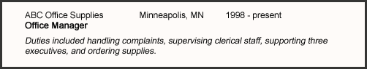
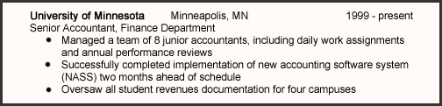

JOB SKILLS (required at this point in your lives)
Include this section to emphasize specific skills, qualities, abilities and accomplishments.
- Use bullets – but no more than five
- Make short statements
- Look again to your inventory summaries for good statements

Sample:
- Punctual and responsible worker
- Able to handle deadlines and work under pressure
- Bilingual – fluent in English and French
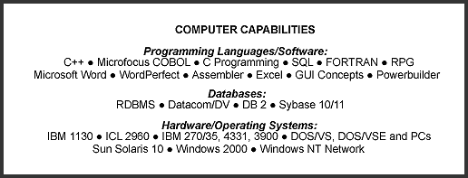

COMMUNITY INVOLVEMENT (if you have done anything – this section is a MUST)
Your volunteer activities provide important information to employers about your personality, interests and skills.
- Describe each volunteer activity
- List in reverse chronological order – what you did most recently first …
- State your job, the name of the organization and the date you were there
- use action verbs to show you are a person who gets things done

Sample 1:
Meal Deliverer, Meals on Wheels, Kitchener, ON, 2000 – present
- delivered more than 500 meals to live-at-home seniors
- provided ongoing advice and assistance as required

Sample 2:
Fund raiser, Terry Fox Run
- raised $100 in pledges, walked 10 km., Sept. 2005

INTERESTS (optional)
This section is optional but use it if this information has not been revealed yet in your resume.
- Be brief but specific
- Show your range of interests

Sample:
Reading fiction, exploring Web Design programs, snowboarding at Chicopee Ski Center, caring for a range of pets, watercolour painting

REFERENCES (optional)
Some suggest providing references only when they are requested. Be prepared with a list of references that will support your candidacy. A good reference will be able to talk about your work experiences and skills. Be sure to get their permission to be included on your list and ask them whether they will be positive. Be sure to let them know what you’ve applied for when you use their name so that they can be helpful and not surprised when contacted.
If you choose to include this section, record one or two people who have given you permission, to supply their names and phone numbers to potential employers.

Sample:
Mrs. D. Jakub, teacher at St. Mary’s High School, Kitchener, 745-6891 (school)

Or: Available upon request.

